Skyline Small Molecule Targets

The Skyline Targeted Proteomics Environment provides informative visual displays of the raw mass spectrometer data you import into your Skyline documents. Originally developed for proteomics use, Skyline has been extended to work with generalized small molecules. There are many tutorials available that will help you use Skyline for various types of analysis (SRM, MS1 Filtering, DIA, Targeted MS/MS etc). This tutorial concentrates on the differences in using Skyline for targeting small molecules.

In this tutorial, you will build an MRM assay for a group of Methionine-pathway compounds.

Skyline aims to provide a vendor-neutral platform for targeted quantitative mass spec research. It can import raw data from the instrument vendors Agilent, SCIEX, Bruker, Shimadzu, Thermo-Scientific and Waters. The ability to import data across various instrument platforms greatly facilitates cross-instrument comparisons and large multi-site studies. This remains equally true in using it to target small molecules, as it has been for years in the field of proteomics.

# Getting Started

To start this tutorial, download the following ZIP file:

<https://skyline.gs.washington.edu/tutorials/SmallMolecule.zip>

Extract the files in it to a folder on your computer, like:

C:\Users\bspratt\Documents

This will create a new folder:

C:\Users\bspratt\Documents\SmallMolecule

It will contain all the files necessary for this tutorial. Now start Skyline, and you will be presented with a new empty document.

# Importing a Small Molecule Transition List into a Skyline Document

The easiest way to get a small molecule transition list into a Skyline document is to start with an empty document and use the **Edit > Insert > Transition List** menu item. [Note: the **File > Import >Transition List** menu item does not yet work for non-proteomic data – it’s not good at guessing which columns are which in a small molecule transition list.]

At a minimum, Skyline needs to know the charge state and either the ion formula or m/z for each precursor and product. If no product ion information is present, it is assumed to be a list of precursor targets. Repeated precursor information with different product information is assumed to indicate multiple transitions of a single precursor, just as with peptides.

### A note on ion formulas

In proteomics applications Skyline can safely assume ionization by protonation. So, all that is needed to describe a charged peptide is its sequence and charge state. Skyline just adds protons (hydrogen minus an electron) to the underlying chemical formula as needed. For generalized small molecules, however, ionization can be achieved by almost any means (sodium gain, hydrogen loss, etc). The most reliable and flexible way to describe this for Skyline is with ion formulas. That is, if your singly charged molecule is ionized by sodium gain, you must add a sodium atom to the chemical formula you specify in the Skyline interface. (Note: It is also possible to describe your transition list completely in terms of m/z values for both precursors and products, but without a chemical formula Skyline cannot provide isotopic distributions).

## Transition list insert

To begin creating your first Skyline document that targets small molecules, do the following:

* Locate the “SMTutorial_TransitionList.csv” file and open it in Excel.
* On the **Edit** menu, choose **Insert** and click **Transition List**.

Skyline will show the **Insert** form, which may start out looking like this:

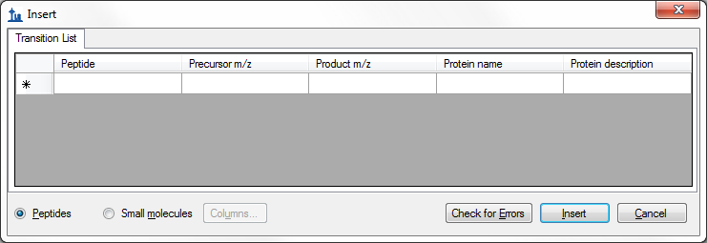

If it does, you can change it to accept small molecule fields by doing the following:

* Click the **Small molecules** option at the bottom of the form.

The form should now look like this:

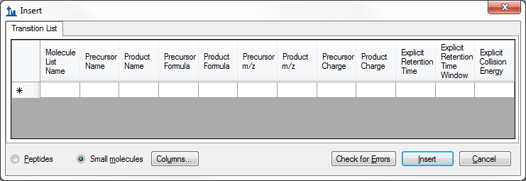

In the transition list spreadsheet, you should find the following values:



You can see that there are some extra column headers in the **Insert** form, and the column order is not the same in the form as in the spreadsheet. Both issues are easy to correct:

* Click the **Columns** button and uncheck the columns that do not appear in the spreadsheet.

This should result in a column picking menu like the one shown below:

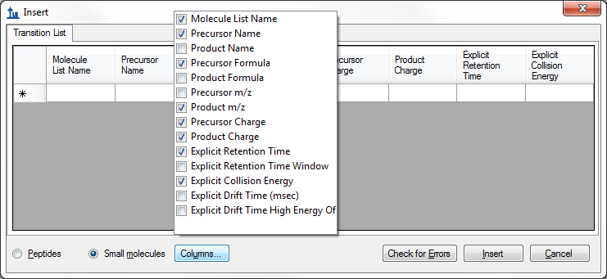

Next do the following to reorder the columns in the **Insert** form:

* Click and drag each column header you want to move to the order matching the spreadsheet.

The insert form should now appear as shown below:

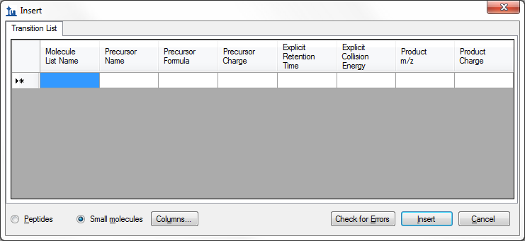

To add the transitions specified in the spreadsheet, do the following:

* Select the contents of the spreadsheet, excluding the first row containing the headers.
* Click the **Copy** button on the toolbar.
* Switch back to Skyline.
* Press Ctrl-V on your keyboard to paste.
* Click the **Check for Errors** button.

NOTE: If you accidentally copied the header row or got the column order wrong, then you will see an error at this point. Otherwise, the **Insert** form should look like this:

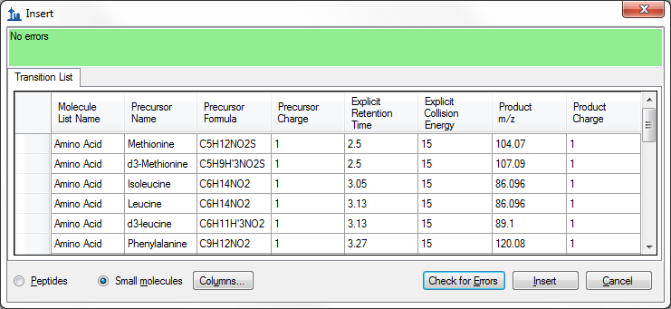

* Click the **Insert** button.

Your Skyline window should now look like:

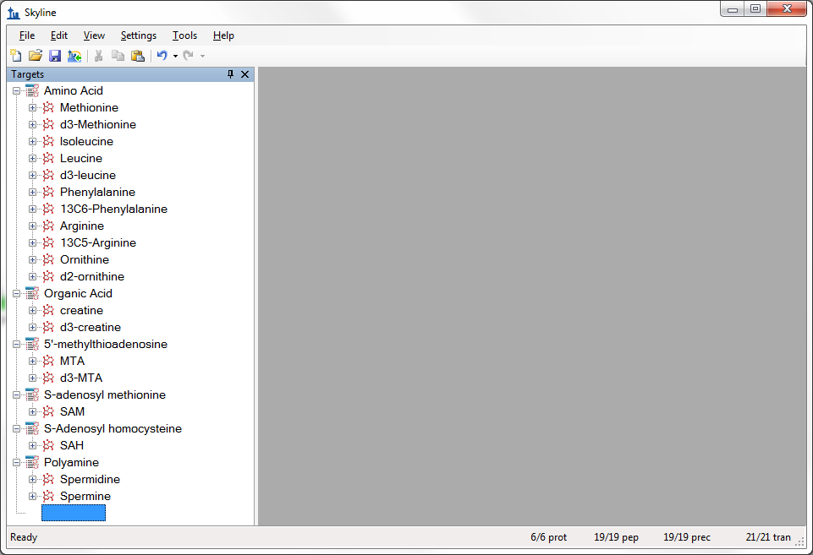

Note that some of the targets are light-heavy isotope label pairs, e.g. Methionine and d3-Methionine. If you are familiar with how Skyline groups isotope label type precursors within a single peptide element, you may see this as a missing feature for small molecules. That should be remedied fairly soon.

At this point, either a native instrument method, precursor isolation list (for PRM) or transition list (for SRM) can be exported. For more details on how to perform this step, please see the [Targeted Method Editing](https://skyline.gs.washington.edu/labkey/wiki/home/software/Skyline/page.view?name=tutorial_method_edit), [Existing and Quantitative Experiments](https://skyline.gs.washington.edu/labkey/wiki/home/software/Skyline/page.view?name=tutorial_existing_quant) or [Targeted MS/MS (PRM) tutorial](https://skyline.gs.washington.edu/labkey/wiki/home/software/Skyline/page.view?name=tutorial_targeted_msms).

## Importing mass spectrometer runs

In this tutorial, you will simply import raw data from a Waters Xevo TQS instrument acquired using a MassLynx instrument method exported by Skyline. To do this now, perform the following steps.

* On the **File** menu, click **Save**. (Ctrl-S)
* Save this document as “Amino Acid Metabolism.sky” in the tutorial folder you created.
* On the **File** menu, select **Import** and click on **Results**.
* Click the **OK** button in the **Import Results** form to import single-injection replicates.
* Select all 18 raw data folders in the tutorial folder by clicking the first listed and then holding down the Shift key and clicking the last.

The **Import Results Files** form should look like:

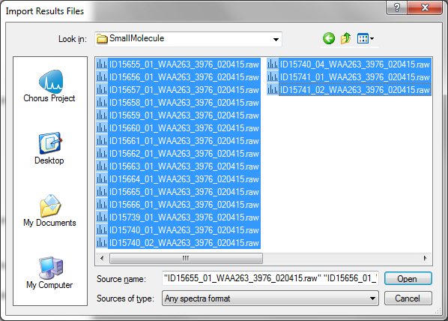

* Click the **Open** button.
* Click the **Do not remove** button when asked about removing the common prefix.

The files are a metabolite extract of cancer cell lines under specific amino acid deprivation conditions, where cells were deprived of either the amino acid Methionine, or Arginine, or both, for a period of 3 hours versus control (all amino acids).1

Filenames and Conditions:

ID15739_01_WAA263_3976_020415 – double blank

ID15740_01_WAA263_3976_020415 – Extraction Blank (contains SIL standards)

ID15740_02_WAA263_3976_020415 – Extraction Blank (contains SIL standards)

ID15740_04_WAA263_3976_020415 – Extraction Blank (contains SIL standards)

ID15655_01_WAA263_3976_020415 – All AA Sample 1

ID15656_01_WAA263_3976_020415 – All AA Sample 2

ID15657_01_WAA263_3976_020415 – All AA Sample 3

ID15658_01_WAA263_3976_020415 – Minus Met Sample 1

ID15659_01_WAA263_3976_020415 – Minus Met Sample 2

ID15660_01_WAA263_3976_020415 – Minus Met Sample 3

ID15661_01_WAA263_3976_020415 – Minus Arg Sample 1

ID15662_01_WAA263_3976_020415 – Minus Arg Sample 2

ID15663_01_WAA263_3976_020415 – Minus Arg Sample 3

ID15664_01_WAA263_3976_020415 – Minus Arg, Minus Met Sample 1

ID15665_01_WAA263_3976_020415 – Minus Arg, Minus Met Sample 2

ID15666_01_WAA263_3976_020415 – Minus Arg, Minus Met Sample 3

ID15741_01_WAA263_3976_020415 – Pooled QC Sample 1

ID15741_02_WAA263_3976_020415 – Pooled QC Sample 2

The files should import within a matter of seconds, leaving your Skyline window looking like:

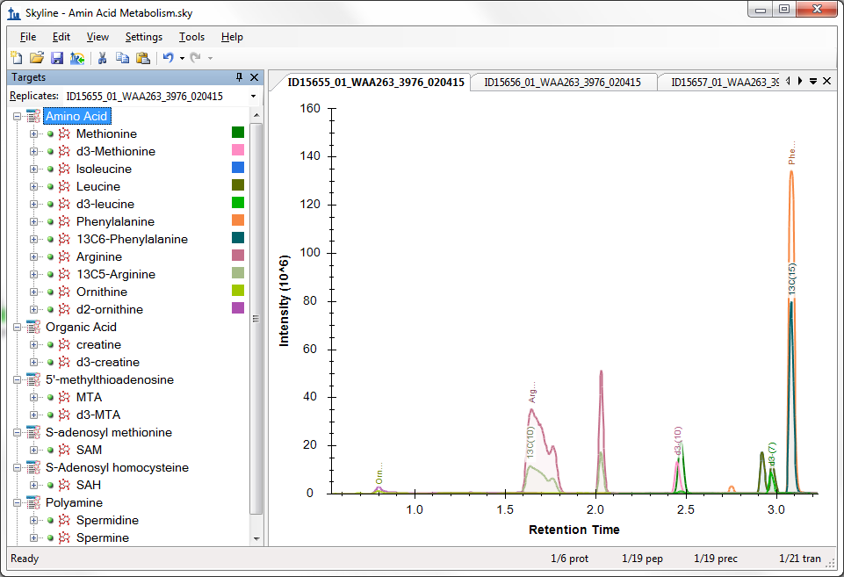

To take advantage of the Skyline summary graphs for viewing individual targets, do the following:

* On the **View** menu, choose **Peak Areas** and click **Replicate Comparison**.
* On the **View** menu, choose **Retention Times** and click **Peak Areas**.
* Click and drag these views to dock them above the chromatogram graphs.
* Select the first target “Methionine” in the **Targets** view.

The Skyline window should now look something like this:

# 

# Conclusion

In this tutorial, you have learned how to create a Skyline document that targets small molecules specified as precursor ion chemical formulas and product ion m/z values. You imported a multi-replicate data set collected by a metabolomics researcher, and saw how many existing Skyline features created initially for targeted proteomics use can now be applied to small molecule data. Small molecule support is still a relatively new feature area for Skyline. As such, you can expect it to continue improving rapidly.

# Bibliography

1. Tang, X. *et al.* Comprehensive Profiling of Amino Acid Response Uncovers Unique Methionine-Deprived Response Dependent on Intact Creatine Biosynthesis. *PLoS Genet* **11,** e1005158 (2015).